Motivation through Gamification
Kristina Allison
California State University, Sacramento
Abstract
The purpose of this study is to describe the effects of integrating gamification in the middle school classroom as a motivational tool to increase student engagement and assignment completion at increasing levels of learning in an independent reading unit. Gamification can be defined as the use of game design and elements in the classroom (e.g. levels that gain complexity, extrinsic rewards and player choice) on non-game curriculum. Although not a formal pedagogy, gamifying tends to have similar components to games: mechanics, dynamics and aesthetics. This can be a powerful motivator if it encourages further engagement. This study looked at how using gamified elements affected engagement and motivation in students to reach higher taxonomies of learning or categories of cognitive learning behaviors. It also assessed how gamifying the curriculum affected student attitudes toward learning and completing assignments. The study was conducted in two 8th grade language arts classrooms where students completed the traditional unit of study first, and then followed with a gamified version. The lesson design included tasks for students to complete as they read a book independently. These tasks increased in cognitive levels according to the taxonomies of learning. The units were the same, with the only difference being the gamified elements during the second unit. The study compared the results of student engagement in the traditional unit, and the unit that used gaming elements (levels, choice and extrinsic rewards) along the way.
Keywords: gamification, independent reading, motivation

Motivation through Gamification
One goal of the middle school language arts teacher is to get students to comprehend higher levels of reading. In looking at the research, it is obvious that one way to get there is simply by getting students to read more on their own. We know that good reading habits are a strong predictor of success in high school, as well as college and into the workforce. It is also evident that peers can have a strong influence on whether or not students pick up a book. It is also understood that students are far more motivated to read, if they are given a choice in what is read. Choice texts can be done on a student’s own time, while more rigorous texts can be tackled during teacher led instruction. But how can we get students motivated to pick up a book? Here is where gamification can be the answer. With basis in self-determination theory, people are motivated if they feel they are in control. By allowing students choice in what books they read and what activities they choose to accomplish gamification can motivate the student to feel he has control in his own reading journey. Achievements or badges can be used to give students extrinsic motivators. Having assignments on a gameboard that gives rewards along the way can help motivate students to continue reading and completing assignments, as well as encourage them if they start to lose interest. Badges at each milestone recognize students on their perseverance incrementally, without having to complete a larger task. Having a leaderboard posted in the class can also motivate students. Those who enjoy competing can see the results of their hard work, because they are placed at the top. As mentioned, middle school students are also highly influenced by their peer interactions with books. By seeing their peers on the leaderboard, as well as witnessing the awarding of badges, others can be motivated to do the same. By making the game accessible, incrementally challenging, and rewarding student can be motivated to pick up a book and practice the necessary skill of independent reading.
The purpose of this study was to describe the effects of integrating gamification in the middle school classroom as a motivational tool to increase student engagement and assignment completion at increasing levels of learning in an independent reading unit. Middle school students are often unmotivated and fail to complete assignments, especially when it comes to independent reading done for homework.
In this study, eighth graders participated in, first an independent reading unit with a traditional structure, then the same unit with gamified elements: leaderboards, or a listing of player rankings, prizes, or rewards, embedded choices, and badges, or achievements, (in this case stickers). Through the tracking of assignments scored on a rubric, students’ motivation and quality of work completion were tracked and measured to find if the unit with the added gamified elements made a difference in student engagement and learning. Students were also surveyed for their opinions on the experience of both the traditional unit of study and the gamified version in reference to their attitudes and motivation for reading. Additionally, this study recorded the cognitive learning levels of the assignments students chose in order to track if students chose higher-level assignments.
Research questions and/or anticipated outcomes
How will using gamified elements affect engagement and motivation in students to problem solve and reach higher levels of learning?
How will gamifying the curriculum affect student attitudes toward learning and completing assignments?
Definitions/Key Words
Gamification/gamifying: the use of game design and elements in the classroom (e.g. levels that gain complexity, extrinsic rewards and player choice) on non-game curriculum
Motivation: desire or willingness of someone to do something
Taxonomies of Learning (higher versus lower levels): Categories of cognitive learning behaviors.
Review of Literature
The middle school years are a unique time in the educational journey of a person. Often students find themselves falling short of expectations and standards, where in years prior, they were able to keep pace. Teachers often equate this with increased expectations of the curriculum coupled with increased independent responsibility. The standards for adolescents increase with rigor, but often student motivation drops off. Adolescents are often more concerned with extracurricular activities and peer relations, and often are not interested in completing high level tasks on their own. This is certainly true when it comes to meeting the standards for reading. As the Common Core standards are written, it is essential that students continue to read rigorously over the course of each grade level. The amount of reading required to get students ready for high school and beyond cannot be accomplished simply through classroom activities. The need for students to continue independently reading is great. Of course, how can we encourage students to pick up a book and read on their own? The real challenge then becomes motivating students. Finding ways to intrinsically motivate students is a dilemma every classroom teacher has experienced. While there is no perfect answer, looking at ways adolescents are motivated can give some insight. Taking a closer look at games is a start. Students are often motivated by video games that include elements like levels, badges/rewards and leaderboards. Video games use extrinsic rewards to create intrinsic motivation. Understanding these extrinsic rewards that keep kids playing might be a way to build motivation for students in the classroom.
The Importance of Independent Reading
Independent reading is the reading that students do on their own, usually outside instructional time. It is often choice selections and designed to encourage fluency and promote pleasure. It is widely recognized that independent reading is not just important, but fundamental for success in school and beyond the classroom walls. However, research indicates that many students do not choose to read on their own. In fact, a study by Anderson, Fielding and Wilson (1988) found that students spend less than two percent of their free time reading. The numbers increase as students get older, as well, especially in the middle school grades. A survey of 159 seventh and eighth graders reported reading independently up until seventh grade, then ceasing completely in eighth. Students only read material that was assigned or required (McCoy, 1991). Nothing is read simply for pleasure. Reading outside of school and for pleasure closes the literacy gap and better prepares students for higher education and success outside the classroom.
The Link to Success. There is some research that cites that light reading can be a stepping-stone for these reluctant readers. Researchers Dorrell and Carroll (1981) placed comic books in a library of a middle school and did not allow students to check the books out. Students had to visit the library to read. The researchers compared library use with circulation and found that the visits increased by 82 percent, whereas the circulation increased by 30 percent. It seems that the light reading might be a way to hook middle school readers, but moving to more difficult texts is needed for growth.
Another issue is what teachers have also referred to as the “Summer Slide.” This is when students are performing at or above grade level in June, but when they return in the fall, they have regressed. Heyns (1978) studied sixth graders from various racial and socioeconomic groups and found that the single summer activity that helps stop the slide and increase learning is reading. If that is the one thing students can do to improve their learning, then they need to not just be doing it in the summer, but year round. It is also recognized by scholars that exposure to print is a good predictor of spelling, vocabulary knowledge and general world knowledge. Cunnnigham and Stanovich (1991) assessed middle school students with a book title recognition test and correlated that print exposure contributes to the development of verbal abilities. Using this data compiled with several other studies, Cunnnigham and Stanovich (1991) also found that print exposure was a predictor of success in spelling, vocabulary knowledge and general world knowledge. It seems the more students are exposed to the written word, their likelihood for success in school increases.
Literacy as a Social Process. There is a high correlation between high scores on reading assessments and students who admit to having a high intrinsic motivation to read (Krashen, 2004). This motivation, however, may be explained at the middle school level with the social aspect of literacy. In 2010, Matthew Knoester from the University of Evansville conducted a case study of ten fifth, sixth and seventh grade students and suggested that reading is part of a social process. Parents of six of the ten reported that their students read without being prompted, the remaining four read, but only with pressure. Knoester’s most surprising finding, though, was the numerous examples where reading was tied to social interactions. Students loved talking about their books with their parents and also really enjoyed reading aloud at home. He found that students who read for pleasure do the following: discuss books, read similar books as friends and family, read along with friends and family, and read aloud to others (Knoester, 2010). To encourage middle schoolers to read, teachers must understand how important the social aspect is to their relationship with reading. This includes discussions, book recommendations and a general sharing of literacy in peer to peer, as well as parent to child relationships.
The Challenge of Deeper Reading. While encouraging students to read on their own outside of school seems to be the best way to ensure continuous learning, the challenge still exists in getting students to be successful readers of grade level materials, as the Common Core Standards demand. Independent reading involves choice selection by the reader, but students need to be able to read and comprehend grade-level texts with proficiency.
The Problem with Accelerated Reader. Many schools have used computer programs to track progress, most notably with the Accelerated Reader program. This is a program that was created to give students large amounts of reading practice with material geared at a student’s own reading level, with achievements specifically designed for the reader, namely points with individual goals. Through a computerized quiz, AR measures simple comprehension of books read. Students earn points based on how well they do on the quiz and the complexity of the reading level. This sounds like it could be a great motivator, but many studies have pointed otherwise. One study of two hundred and seventy fifth grade students in Jackson, Mississippi found that students who participated in the Accelerated Reader program had no significant increase in reading achievement than those students who did not (Melton, Smothers, Anderson, & Fulton, 2004). An earlier study found similar results with a sixth grade class. The first year the students used the program, the next year the students did not. The results indicated that after a year of exposure to the program there was no increase in comprehension scores on the Stanford Achievement Test (Mathis, 1996). Findings like these point to a problem with the design of the program. Perhaps simply testing students on simple comprehension (e.g., did they read the book?) is not enough. Teachers must find a way to meet the rigor of the standards if comprehension is to be improved.
The Balance of Choice and Rigor. Using an approach that combines choice independent reading and grade-level texts, might be a way to meet the end of the year Common Core Standards. The classroom must be a place of rigor as well as building motivation and self empowerment. A reader’s workshop model, where students are given choice of independent reading is a popular approach to motivate students to read more, but it does not address the rigor of the standards. In-depth exploration of a text during close reading is still needed in the classroom. In one study from the University of Wisconsin, Whitewater examined the effectiveness of this dual focused classroom. Five teachers in grade six and four in grade seven with approximately 280 to 260 students implemented a workshop structure, that began with a read aloud. In a survey of the students, 91% cited choice, extended time to read and book clubs (all elements of workshops) as positive experiences. Teachers chose to use higher level texts during this read aloud to meet the rigor of the standards. They also included a wide range of print and media, as well. In addition, the teachers modeled how to read and interrogate texts, so students could access previously inaccessible texts (Stevens, 2016). By implementing a strong independent reading program, students were more motivated to read. However, they were still able to meet the needs of the rigor of analyzing grade-level texts through mini lessons and read alouds.
Another way this model was successful was utilizing the book club format, or collaborative grouping. Here students were given the opportunity to investigate their own questions while collaborating with others in the group. Students started with easier texts and through teacher scaffolding, learned how to formulate their own discussions and dig deeper into text. By allowing students to discuss grade level texts in these groups, they can work toward independence (Stevens, 2016). Students can then use these higher level inquiry skills to access more difficult reading on their own.
Stamina, Fluency and Student’s Connection to Books. As students enter middle school and the independent reading slows and sometimes halts for some students, the demands for reading for all intensifies. Thus, the gap between the reader and the non-reader begins to widen exponentially. The trick to closing that gap is more reading. The amount of reading expected in college is staggering for most recent graduates. In middle school and high school we must build that stamina to make students successful. Reading a lot is what makes you good at reading. Students can not do it on their own, though. As Penny Kittle writes, “Readers need books that carry them along, compelling them to read. Readers need goals for the quarter, for the year, and we need to pay attention to quantity as well as quality in their reading lives” (Kittle, 2013, p. 8). Designing a classroom that facilitates reading is key to the success of independent learning. This includes books that students enjoy in which they can make a connection, books they can access at their level, as well as a teacher to hold them accountable. Independent reading is vital for student success and designing an environment for its success is necessary in the classroom.
Student Motivation
Having already discussed the necessity for student independent reading, especially in the middle school years, motivation to complete the task becomes our focus. Motivating middle school students to complete assignments, especially outside the classroom can be a difficult task. Getting students to complete higher-level cognitive tasks, like analyzing text as the Common Core Standards demand, is even more of a challenge.
The Power of Choice. First, we must examine the effectiveness of choice in the classroom. Teachers have long reported that allowing students options in their instruction enhances motivation (Flowerday & Schraw, 2000). Of course this is a perceived notion, based only on what teachers assumed in their classrooms. Consequently, Patall, Cooper and Wynn (2010) conducted a study in a high school classroom where they used homework as the central focus for choice. Knowing that students who complete homework are far more likely to get higher scores on tests, it’s vital that students complete the homework. By using choice, the study was examining if providing choice of homework assignments could, as Patall, Cooper and Wynn, (2010) wrote, “facilitate learning outcomes, including greater intrinsic motivation and perceived confidence” (para. 4). Teachers developed two versions of homework assignments. Students were offered a choice, while a control group was not given an alternative. Both were then given the same unit tests. The results were quite favorable for the students who had the choice homework assignments. Students felt more interested and enjoyed the homework more with a choice. They tended to complete more of the homework and scored higher on the tests (Patall, Cooper & Wynn, 2010). It should be noted that students were given a choice between two homework assignments that covered the same material, so the curriculum was not changed. The students had more of a perceived notion of choice. However, simply giving them a small choice, gave them an element of control and therefore had a larger buy-in.
In looking at self-determination theory, choice is an important part of an individual’s feelings of autonomy and motivation. According to self-determination theory, autonomy, competence and relatedness along with the social atmosphere to enhance these three, are what people need for intrinsic motivation (Ryan & Deci, 2000). Therefore, students need a sense of control and understanding in the classroom. It is vital for student motivation. It is also understood that the choice does not need to come from the student entirely. It is perceived choice of an individual that is related to his or her performance outcome (Patall, Cooper & Wynn, 2010). This means that simply allowing students to choose from two options will give them a feeling of control, thus motivating them.
Internal Locus of Control. The Hamlet Project, used technology to motivate students to read, comprehend, and interpret Hamlet. The project moved students through a computer-generated unit where students had choices along the way. They found that students were motivated by the activity because it provided challenge, curiosity, control and fantasy (Abate, Steele, Bogard, & Hutchings, 2004). Referencing self-determination theory, as well, the study pointed out that, “Self-determination theory says that while we can’t make a person intrinsically motivated in something, the individual's internalization of the other’s values and needs can bring extrinsic motivation to a level at which it is as close as possible to intrinsic motivation and include an internal locus of control” (Abate, Steele, Bogard, & Hutchings, 2004, para. 5). Consequently, motivating students to complete challenging tasks and persevere is what will get them to learn.
A study at a non-technical university in Japan examined the effectiveness of student choice in curriculum. At the end of a unit, students were given a choice as to how they would like to present their end of the term project. The choices were Power Point, (which many were familiar), or in digital storytelling form. The study evaluated 53 students. Out of the 53, only 8 chose digital storytelling, the more time consuming of the two. However, students unanimously agreed that having selectable styles of expression for their project were good for them, allowing them some control over their own assessment. However, most students felt that the two choices were not equally challenging. Some students felt too anxious to choose digital storytelling, although they would have liked to learn more about it (Kasami, 2011). It seems having a choice that students perceive as “fair” may also be a critical factor in choice.
The goal in motivating is always to get a person to be intrinsically motivated, meaning do the task just for the sake of doing it. For students this would mean completing assignments simply because they want to learn. The problem becomes using extrinsic motivators, (grades, rewards, etc) to create intrinsic motivation. Choice could be the answer to this dilemma.
“One goal of education is to cultivate students’ individual interest in a topic, thereby cultivating ongoing curiosity and exploration, and ultimately, long-term learning” (Dobrow, Smith & Posner, 2011, p. 262). A study conducted by the aforementioned looked at MBA students and challenged the notion that they were merely working in their programs for a grade, not for learning. Their study highlighted the idea that extrinsic rewards (ie. grades) actually reduce intrinsic motivation. How can they reverse this phenomenon? Their answer was by giving students a choice to increase interest. Ninety-one MBA students from two universities participated. Fifty-three participants participated in the choice condition and thirty-eight in the no-choice condition. At the beginning of the semester students were told that they would be able to make grade allocations in the third week of the semester. That is, they could decide what percentage of their assignments--class participation, case analysis, and final group project--would make up their final grade. However, once submitted, they could not change. The results were measured by responses on a final survey. The study found that giving students a choice triggered situational interest, or satisfaction with the course, but also maintained that interest with students responding that they were interested in taking another course (Dobrow, Smith & Posner, 2011). Simply by giving students the ability to choose their own weight on assignments, gave them the sense of control that maintained their interests, motivating to achieve.
Gamification
While choice seems to be an effective answer for student motivation, gamifying the classroom will also motivate students to, not only master content knowledge, but persevere through tasks the average student would believe too difficult. Games in the classroom have been popular and highly effective for decades. However, gamifying is a fairly new technique from the past five years or so. It is gaining popularity and for a good reason. Although not a formal pedagogy, gamifying tends to have similar components: mechanics, dynamics and aesthetics. The mechanics define the way games are actually played. Dynamics guide how players and the game mechanics interact. Aesthetics refer to how the others interact to create cultural and emotional outcomes (Dicheva, Dichev, Agre, & Angelova, 2015).
Designing a gamified lesson presents some challenges, but good design is essential in a successful implementation. First, the goal must be clearly established before design begins, as with any well-crafted unit of study. Next, the mechanics must be established. Leaderboards or a listing of player rankings, can be a powerful motivator. Imbedded in game culture are prizes, or rewards along the way. This can serve the purpose of giving characters choices throughout, creating a far more personal experience, but it can also give students extra activities which are unlocked after certain levels are reached. This can be a powerful motivator if it encourages further engagement. Achievements should also be highlighted for the players. This can take the form of “badges” or simple icons to display on either an online profile or a physical bulletin board (Glover, 2013).
Increasing Learning and Motivation. While the concept is still relatively new, some studies have pointed to the hope that gamification does, in fact, increase motivation. One study of undergraduate cell biology students were offered the use of a computer game to learn information also taught in lecture. Fifty students from Plattburgh State University were given the option to play the game, but every student chose to play. The scores on the game were exceptionally high. On the exam, the scores for one question taught in lecture and included in the game was compared to a question taught in lecture and not played on the game. The class did 27.2% better of the question included in the game. These results show that a computer game, that offered points and rewards was more successful than lecture alone (Slish, Nash, & Primo, 2015).
Another study from the University of Bremen, evaluated the use of a mobile application (app) to learn the writing of Japanese characters, the kanji. The first version was a simple app, allowing practice in drawing the characters in a flashcard type setting. A second version was developed using gamification elements. In this one, if a user drew the character correctly, it would release magic to fight other characters. The participants used the apps for two weeks. The success rate of the first group was fairly high in learning the characters, 80%. The gamification group was slightly higher. However, the study also indicated that the gamified app was accessed more often. One could infer that this indicates a higher motivation by the users, thus, concluding the possibility that gamifying is a successful motivator (Sauerland, Broer & Breiter, 2015).
By applying game elements to a teacher education course, one study was able to show pre-service teachers just how effective this phenomenon can be. At Brock University, one hundred and thirty-three pre-service teachers participated in a gamified course on how to teach with technology using the TPACK (Technology, Pedagogy, Content Knowledge). The course work, including readings, videos and structured tasks, was chunked and listed on a hosted website. Grade points were assigned to each site and a badging system (achievements) was added to record completion of each task. At the end of the class, a survey was given to measure results. The findings concluded that the students felt they had learned the material in a positive environment. The majority indicated that they actually implemented the TPACK model during their lessons (85%). Before the course, only 50% used technology during their lessons. Of course, the majority of participants could describe the TPACK model and its implementation, having learned the material in a gamified unit. The knowledge was acquired (Figg & Jaipal-Jamani, 2015).
Criticism of Gamification. Being such a new style of teaching in the classroom, with its trials, also comes quite a bit of criticism. It is important to understand the pitfalls of gamification, in order to avoid creating curriculum that is ineffective in motivating. First, when creating a unit, it is important to understand your goal. So many gamified projects fail miserably because the goal has not been clearly set. You must consider various outcomes. Is your goal to get kids to turn in homework on time? Better retention time? Know what you want to accomplish before you begin. Next, you should know your audience. Bohyun Kim, in Understanding Gamification, references classification of players: player (motivated by extrinsic rewards), socializer (motivated by relatedness), free spirit (motivated by autonomy), achiever, (motivated by purpose). It is important to decipher the kind of classroom you have before designing (Kim, 2015).
You must also be aware of variables such as gender, age, culture and academic performance. Girls are far less likely than boys to enjoy competitive video games. Also, serious games tend to benefit students with less self-motivation and lower grades. Not all games are effective with different types of content. Card games and jeopardy are great for lower level content knowledge retention, but not a higher-level skill that needs an open-ended environment. You must design your game to fit the content goal (Kim, 2015).
The biggest criticism of gamification revolves around extrinsic rewards and intrinsic motivation. The goal for the student is not the reward, or achievement badge. The goal should be to motivate students to complete the task and acquire the knowledge. One way to combat this is not to have external rewards. Teachers can allow students to set their own goals or guide students to set their own choices. The challenge then becomes to create a task that is sufficiently motivating and fun without the reward. Gamification itself does not automatically motivate students. Students have to want to play along. They have to be intrinsically motivated to complete the task (Kim, 2015). In “Play as you Learn: Gamification as a Technique for Motivating Learners,” Glover suggests that rewards also need to be achievable and desirable in order to provide sufficient extrinsic motivation, but scarce so that student might feel that sense of accomplishment without the reward. Even no cost on-line badges should be used sparingly (Glover, 2013).
Discussion
In looking at previous studies and literature, first it is vital to look at the importance of independent reading for the middle school student. Reading independently promotes long-term learning, helps students meet standards, increases rigor and stamina for future success, as well as promotes a connection to books that will serve students throughout school and beyond. Beyond the importance of independent reading, student motivation is highlighted.
The power of choice and extrinsic motivation leading to intrinsic motivation validates the concept of gamification as a tool for motivation in the classroom. The case for gamification is then made as a way to motivate middle school students to independently read. Games in the classroom have been popular and highly effective for decades. Taking similar components of games: mechanics, dynamics and aesthetics, gamifying has become a recent trend. Research points to its potential success in the middle school classroom.
Deficiencies in Current Research. While many studies have been conducted on students using gamification techniques, it is still a fairly new concept in education. Of course, games have been used extensively in education. Computerized games that practice reading, math and other skills and measure progress are still used with great success throughout education. However, using gaming elements and applying them to a non-gaming curriculum is not implemented as extensively. As for using gamification as a motivator for independent reading, many programs, such as Accelerated Reader have been tried, with noticeable deficiencies. Looking at a way to get students to connect with standards and with peers might be worth investigating. In the end, teachers are always looking for ways to motivate their students. Gamification presents a welcome opportunity to not only get students to complete reading and homework, but to be motivated to learn.
Direction of this Study
Due to the introduction of the Common Core reading standards and the understanding of the need for more stamina in reading and a rigorous understanding of text, this study focused on motivating students to read independently by using gamification elements, while still meeting the rigor of the standards. It took into account the need for peer interaction, higher levels of comprehension demands, as well as the need to simply get students to turn in assignments connected with their reading.
Methods
The study was conducted using middle school students who, first, completed a traditional unit of study, then followed the unit with a gamified version. The lesson design included tasks for students to complete as they read a book independently. These tasks increased in cognitive levels according to the taxonomies of learning. The units were exactly the same, with the difference being the gamified elements during the second unit.
Setting
Two English language arts classroom were used in the study at Barbara Chilton Middle School in Roseville, California. Chilton serves about 600 students in the Westpark area of Roseville. In 2015-16, Chilton had the highest percentage of students scoring meet or exceeds standard in Language Arts and Mathematics when compared to all other middle schools in Roseville, based on data from the State CAASPP testing. Students at the school identify themselves as predominantly white, with the second largest demographic Filipino or Asian at just under 30%. Only open since 2012, it is the newest middle school in the Roseville City School District. In a middle to high income area, only around 10% of Chilton students are on the free and reduced lunch program.
Participants
Taking part in the study were 47 eighth graders (N=47) from two English language arts classes. All students were 13-14 years old. Most (46) were native or fluent English speakers, while 2 were considered English Language Learners (level 3). Participating were 24 females and 23 males. No students held an individualized education plan (IEP) or were labeled gifted and talented (GATE). Most participants were reading at or above grade level (33 students), while 6 were considered reading one grade below at the 6th grade level, 4 at the 4th grade level, and 1 student was reading at the 3rd grade level.
Measures
Using a mixed methods study and collecting both qualitative and quantitative data results, motivation and engagement were analyzed. Quantatative measures first included tracking assignment completion. Collection of both the gamified and the non-gamified measured how often students turned in assignments. Data were recorded and the percentage of assignment completion for each week was recorded. The traditional and gamified percentages were compared and analyzed for simple completion rate. In addition, assignments were scored on a 2-point rubric scale (Appendix A). The scoring on the rubric gave an indication to the quality of each student’s reading response, in addition to keeping consistency in grading. The rubric was based on the Common Core State Standards for 8th Grade. Each rubric scored assignment was recorded and analyzed using descriptive statistics of mean, medium, mode range and standard deviation.
Both qualitative and quantitative data were also collected from student surveys. At the end of the traditional unit and the end of the gamified unit students were surveyed for feedback on a Likert scale, asking questions about student engagement (Appendixes B and C). Results from these questions were recorded and analyzed using descriptive statistics of mean, medium, mode range and standard deviation. Results of the traditional unit and the gamified unit were compared and motivation inferred. The survey also included objective questions, with some opportunities for student input with open-ended questions. In answer to the question--What did you like about the unit?--student responses were coded defining which aspects of gamification were more engaging to the participants. Students’ answers were coded by the frequency of common word answers: reading, choice of book/assignments, motivating, helped me with my book, easy, giving my opinion, and don’t know /nothing. These were recorded and tallied. For the question--What motivated you to complete the assignments?--answers were coded by frequency of the common phrases: grades, reading/book, deadlines/parent pressure, nothing, fun, recognition by teacher, points/levels/badges, more choice, leaderboard/competition, and completing on a computer. Results of the traditional and gamified were compared and motivation inferred from the most frequently used common words. Results of each survey were compared to see the effects of gamification.
Procedure
Before the study, participants were granted consent from their parents. Each also signed a consent form themselves, agreeing to participate in the study. The two units were designed by creating short writing prompts that addressed multiple standards in reading for literature of the California Common Core Standards. During first part of study (three weeks) students were asked to complete one weekly assignment based on two hours of independent reading and have it completed by Friday (Appendix B). The assignment grid was set up by standards and taxonomies of learning. Moving right, the standards got more difficult and moving downward the levels of learning increased. Any assignment could be chosen, but it could not be repeated the next week. Students completed their assignments in a composition book, and the teacher scored them each Friday on the 2-point rubric (Appendix A). At the end of three weeks, students were given an anonymous survey on their attitudes about the independent reading homework (Appendix C). Scores of assignments were recorded on a spreadsheet. Results of the survey were collected and coded for comparison.
During the second part of the study, students were asked to participate in a unit of the same assignments with the addition of the badges (Appendix D). The grid of assignments was set up to include levels. Students had to complete the first level before moving on to the next. Each assignment was given a point value, and students needed to earn 20 points before moving on to the next level. Students were not limited to only one assignment a week. They could complete as many as they chose. When a level was completed, students were rewarded with a badge (sticker) and a piece of candy. A leaderboard was tallied each Friday and posted with the top point earners. Assignments were then turned in via a Google form for the teacher to review electronically. Students could complete assignments on a Google Doc or take a picture of their written work and turn in electronically on the form. At the end of three weeks, students were given an anonymous survey on their attitudes about the independent reading homework (Appendix E). Assignment scores were added to the spreadsheet. Survey results were coded for comparison.
Limitations/delimitations. Starting the study 49 participants submitted work and survey results for the first traditional unit of study. However, two participants were unable to complete the second, so their information was thrown out. Since the survey was anonymous, their attitudes and opinions are still included in the survey.
With only three weeks for each unit, there were definitely some limitations on the results. If each indent was allowed to go longer, the study might have yielded clearer results. Because there were only three weeks in the gamified unit, students were unable to move to more rigorous assignments. They were only able to complete one or two levels, not moving down the game card.
Timeline. The traditional unit of study began on November 28, 2016, with the first collection of data on December 2. This unit ended on December 16, 2016, with the survey and the collection of the third and final assignment. The gamified unit began on January 10, 2017, with the first submission of reading assignments on January 13. The gamified unit ended on January 27, 2017. Students submitted their final assignment and completed the survey on the same day.
Validity and reliability. Data and results of the two units: gamified and traditional were compared. First, surveys for both the traditional and gamified units were constructed. Students were asked what about their attitudes about reading during each unit, how much reading they completed, as well as what assignments they completed. Students were also asked specifically what motivated them to complete assignments and do the reading, as well as if each unit as a whole was motivating. By ensuring that questions in the two surveys were directed at student motivation the surveys addressed validity. Second, each week the quality of student assignments and completion was tracked monitoring student engagement. Each assignment was reviewed and scored on a rubric. Using the multiple measures of student assignment completion, quality of those assignments, as well as the student survey questions on engagement, the study validity was ensured. Student motivation and engagement was measured through these multiple factors.
Most importantly, by administering the unit first non-gamified, then gamified, the study was reliable. First, data was collected consistently during both units. Assignments were checked at the end of each week, scored and recorded. At the end of the traditional unit’s three-week duration a survey was given, during class time. The same was true for the gamified unit. During the three weeks, assignments were consistently collected and scored, followed by a survey at the end of the three-week cycle. Since each unit only lasted three weeks, participants remained relatively the same in cognitive and academic maturity. Students remained in the same classes for the entirety of the study, leaving no change to their academic environment. However, since students are able to choose the books in which they read for the units, the book for the traditional unit could have been different from the book for the gamified unit. Since the assignment concepts and standards were the same in each unit, though, the score on the rubric scale would have remained the same, keeping the measurement reliable. Observations by the researcher were not taken into consideration, since the study was based on assignment quality and completion and student responses on the surveys. By using the exact same assignments (grid) for both the traditional and gamified units, with only the gamified elements being the exception, study’s reliability was ensured. The only change from the first part to the second was badges/achievements, levels, point values, leaderboard, and the method of submission: the gamified being a web based form.
Results
Data were explored for both the traditional unit and the gamified version and results compared. Descriptive statistics were used to analyze quantitative data. Each answer was given a numeric value, then mean, median, mode, range and standard deviation were used to analyze data (see Table 1).

Table 1
Descriptive statistics results
Item | Mean | Median | Mode | Range | Standard Deviation | Min | Max | Partici-pants
Week 1 Rubric Scores(Traditional) | 1.43 | 2 | 2 | 2 | 0.74 | 0 | 2 | 47
Week 2 Rubric Scores (Traditional) | 1.62 | 2 | 2 | 1 | 0.49 | 0 | 2 | 47
Week 3 Rubric Scores (Traditional) | 1.43 | 2 | 2 | 2 | 0.65 | 0 | 2 | 47
Week 4 Rubric Scores (Gamified) | 1.77 | 2 | 2 | 2 | 0.56 | 0 | 2 | 47
Week 5 Rubric Scores(Gamified) | 1.74 | 2 | 2 | 2 | 0.61 | 0 | 2 | 47
Week 6 Rubric Scores(Gamified) | 1.7 | 2 | 2 | 2 | 0.66 | 0 | 2 | 47
Traditional Survey results Question #1 Did you enjoy reading independently? | 3.71 | 4 | 5 | 4 | 1.24 | 1 | 5 | 49
Traditional Survey results Question #2 Did the assignments motivate you to read more? | 1.78 | 2 | 2 | 2 | 0.69 | 1 | 3 | 49
Traditional Survey results Question #3 Did the assignments motivate you to read more? | 3.27 | 3 | 3 | 3 | 0.76 | 1 | 5 | 49
Traditional Survey results Question #4 How many minutes a week did you read outside of school during THIS unit on average? | 3.1 | 3 | 5 | 5 | 1.52 | 1 | 5 | 49
Traditional Survey results Question #8 Did the unit encourage you to read more? | 1.76 | 2 | 2 | 2 | 0.69 | 1 | 3 | 49
Gamified Survey Results Question #1 Did you enjoy reading independently during this unit? | 3.74 | 4 | 4 | 4 | 1.07 | 1 | 5 | 47
Gamified Survey Results Question #2 Were the assignments engaging? | 3.53 | 4 | 4 | 3 | 0.72 | 1 | 5 | 47
Gamified Survey Results Question #3 Did the assignments motivate you to read more? | 1.98 | 2 | 2 | 3 | 0.77 | 1 | 3 | 47
Gamified Survey Results Question #4 Did you read more during the gamified unit than the last unit? | 2.3 | 2 | 2 | 2 | 0.66 | 1 | 3 | 47
Gamified Survey Results Question #5 How many minutes a week did you read outside of school during THIS unit on average? | 3.28 | 3 | 5 | 4 | 1.39 | 1 | 5 | 47
Gamified Survey Results Question #7 Do you think the unit encouraged you to read more? | 2.21 | 2 | 2 | 2 | 0.66 | 1 | 3 | 47
Gamified Survey Results Question #9 Did you complete more assignments during this unit? | 2.19 | 2 | 2 | 2 | 0.74 | 1 | 3 | 47
Gamified Survey Results Question #10 Did you complete more higher level assignments during this unit than the last one (higher numbered)? | 2.3 | 3 | 3 | 2 | 0.81 | 1 | 3 | 47
Gamified Survey Results Question #13 Did you like this unit better than the unit without the gamified elements? (badges, levels, leaderboard) | 3.53 | 4 | 4 | 4 | 1.32 | 1 | 5 | 47
Gamified Survey Results Question #15 How much would you enjoy continuing this unit with the gamified elements (badges, levels, etc) | 3.85 | 4 | 5 | 4 | 1.06 | 1 | 5 | 47

First, it was found that when it came to the completion of assignments, students in the study turned in finished work at virtually the same rate during the traditional unit as in the gamified unit. During the traditional cycle the rate of completion was 93%, while in the gamified the rate amounted to 92%, marking only a one percent decrease in completion. However, the same was not true for the quality of those assignments. On a rubric scale of 0-2, student scores were better during the gamified unit. Student assignment scores over all three weeks of each unit for the traditional unit averaged 1.49, while in the gamified unit; the mean was higher at 1.73 (see Figure 1).
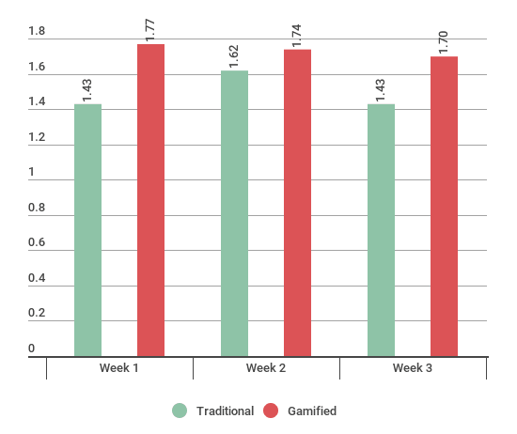
Figure 1. Assignment Rubric Scores. Mean on a scale of 1-2.
Survey results were also compiled and analyzed for the two units. When students were asked if they enjoyed each unit, on a Likert scale of 1-5, students averaged a response of 3.17 for the traditional unit and 3.74 for the gamified. When asked if they enjoyed the gamified more on a scale of 1-5, most agreed at 57.5% giving a rating of 4 or higher (see Figure 2).
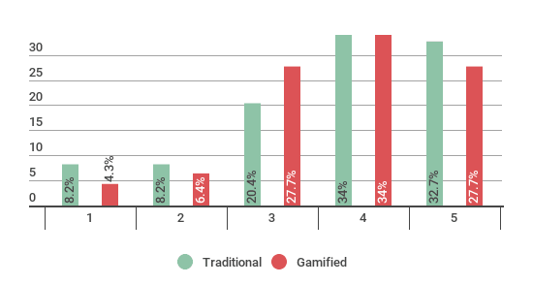
Figure 2. Did you enjoy reading independently?
Motivation was also questioned. Students were surveyed if each unit motivated them to read more. In the traditional unit, 49% answered it was about the same, 36.7% answered no and 14.3% answered yes. Compared to the gamified unit where 51.1% answered their motivation to read more was about the same, 23.4% replied no, and 25.5% answered yes. While the number of students who answered about the same in both units was only slightly different (an increase of 2.1% from traditional to gamified), the number of students who answered yes to the gamified version motivating them to read more increased 11.2% from the traditional unit (see Figure 3).
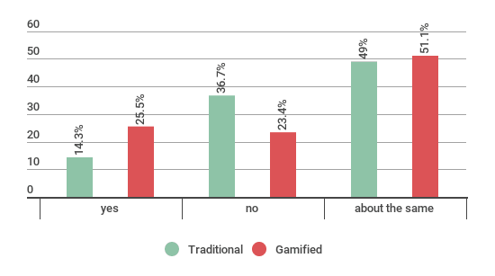
Figure 3. Did the assignments motivate you to read more?
When asked the same question during both units-- were the assignments engaging? --the number of students responding agree and strongly agree was actually higher for the gamified version. During the traditional unit, 40.8% agreed that the assignments were engaging, while no students strongly agreed. Most were neutral at 49%. In contrast, during the gamified unit, 46.8% agreed and 6.4% strongly agreed that the assignments were engaging. Participants answering neutral in the gamified unit decreased to 40.4% from the traditional unit of 49% (see Figure 4).

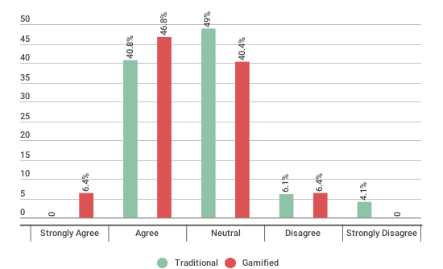
Figure 4. Were the assignments engaging?
Students were also asked how much they read during the unit per week. Results were similar, yet slightly in favor of the gamified unit with 44.9% admitting to reading over 60 minutes during the traditional unit and 46.8% during the gamified. The amount of students not reading at all dropped to 0% during the gamified unit, also (see Figure 5).
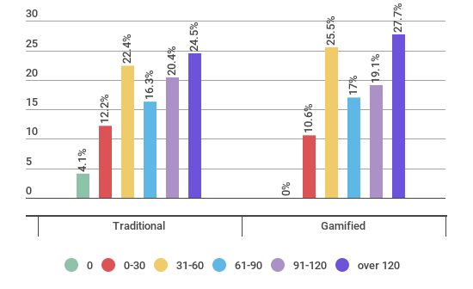
Figure 5. Amount of time per week spent on reading
Data of students’ free responses were also analyzed. A constant comparative analysis was done of the open-ended responses. The researcher analyzed the answers finding predominant themes in comparing all student answers. Through coding of the data into these prevalent themes, similarities and differences were found in the responses for each unit. When students were asked what they liked about each unit, the responses varied significantly from the traditional to the gamified. During the traditional unit, 38 students voiced their opinions on what they liked about the unit. 15 students stated that they enjoyed the concept of choice, the books and/or the assignments. 9 students stated that doing the reading as being the enjoyable factor of the unit, while 7 stated that they liked nothing about the unit (see Table 2).

Table 2
Open ended responses: What students liked about the traditional unit.
Response | Percentage of Students
Reading | 24%
Choice of Book/Assignments | 39%
Motivating | 3%
Helped me with my book | 3%
Easy | 6%
Giving my opinion | 5%
Don’t Know /Nothing | 18%
During the gamified unit, students were asked which aspects of the unit were enjoyable. In this survey, they were given a choice of leaderboard, badges, choice and/or nothing. 30 students stated having a choice, 27 badges and 19 the leaderboard. 5 students answered nothing (see Figure 6).
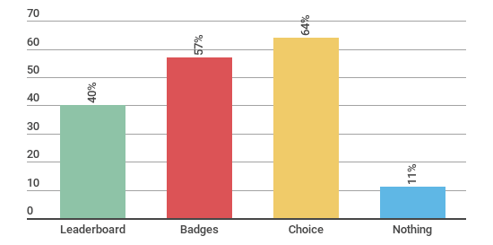Figure 6. What students liked about the gamified unit.
In the each unit, students noted what motivated them to complete the responses on the surveys. Through comparative analysis, coding was used to find prevailing themes in the words and phrases used by students in response to these open-ended questions. These themes were compiled to show a comparison of the traditional and gamified unit. During the traditional unit, grades was the overwhelmingly highest reason for turning in assignments, whereas during the gamified unit the frequency of grades and points/badges/ levels (gamified elements) were equally mentioned (see Table 3). During the gamified unit, many students pointed out that the motivation came from the competition and badges. They enjoyed the game aspect and earning rewards. One student noted that the unit was more fun because of the added features of levels, prizes and points. One even pointed out that since he had to do it anyway for a grade, he might as well earn a prize, too. Only three students answered nothing. One student pointed out that he/she enjoyed turning in the assignments online, instead of writing them on paper. Another mentioned how having a goal gave him/her motivation.
Table 3
Open ended response: What motivated students to complete assignments.
Response | Traditional | Gamified
Grades | 32 | 17
The Reading/Book | 8 | 1
Deadlines/Parent Pressure | 9 | 2
Nothing | 2 | 3
Fun | 1 | 1
Recognition by Teacher | 1 | 1
Points/Levels/Badges | n/a | 17
More Choices | n/a | 2
Leaderboard/Competition | n/a | 5
Completing on Computer | n/a | 1
Participants were also tracked as to what assignments they completed. On the assignment grids (Appendixes B and D), the level of cognitive demand increases the further to the right (by more difficult standard) and down (by level of taxonomy). During the traditional unit, students tended to complete more assignments in the lower range of both. While in the gamified unit, participants completed more high-level assignments (see Figure 7).
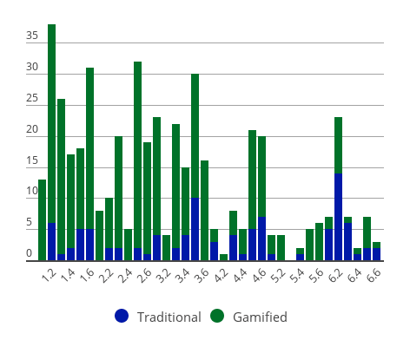
Figure 7. Assignments completed in each unit.
Discussion
Although a small-scale study of gamification, the results of this action research project yielded interesting results. The study set out to see if gamification could motivate middle school students to not just complete their reading assignments, but also to see if it could motivate students to complete higher level tasks. The results were not completely in favor of gamification, but still pointed favorably to gamification as a motivational tool.
The first part of the results measured student motivation through assignment completion. In looking at the traditional unit and the gamified unit and the rate that students turned in assignments, participants did not complete assignments at a higher rate. In fact, the percentage of students who did one weekly assignment actually decreased slightly. Gamification seemed to have no impact on motivating students to turn in assignments. However, an unexpected result occurred with those assignments. When each assignment was scored on the rubric scale, it was obvious that the assignments that were completed were done so with more care in the quality. During the gamifed unit, the quality of student assignments was higher. The difference in method of turning in assignments, however, may have been a factor. In the traditional unit, students wrote in a composition book. In contrast, the gamified responses were collected via a Google form. Students could take a picture of their work or complete the work on an electronic document. Since this was the only difference in turn in procedure, it might be concluded that the quality of the assignments might have been affected by this procedure. More research could be conducted to see if this was, in fact the case.
Another area to take into consideration is that students completed reading and assignments on books of their choice. Some students may have been reading just one book for the entirety of both units (6 weeks) or some may have been reading several different books. Their attitudes on each book could also be a factor in their motivation to read and complete assignments.
The assignments in both units were exactly the same, with the gamified unit only adding the gamified elements. The gamification unit was intended to increase student completion of more challenging assignments. On each of the assignment grids (see Appendices B and D) the level of difficulty got more rigorous as students moved to the right and down the grid. The goal was to get students to choose assignments in the higher levels, the ones worth more points. Of course, unlike in the traditional unit, where students could pick any assignment, students were limited in movement with each level. One could not move to the next level without completing 20 points of the previous. Consequently, many never made it to level 4, 5 or 6. However, because the more difficult assignments within each level had more points, participants did gravitate towards the assignments with higher values. Also, students were allowed to complete as many assignments as they wanted, so many completed higher-level assignments along with the less cognitively demanding ones. There was an incentive to get more points (leaderboard, badges), therefore most students chose to do more than the required one assignment per week.
Gamification did show modest results in the increase of motivation and engagement in student attitude. According to the survey of the traditional unit, students enjoyed being able to choose which assignments to do each week. During the gamified unit surveys pointed to the elements of the game as to why students liked it better, choice being another factor. Students admitted to reading more during the gamified unit and although the assignments did not change from the traditional unit, participants answered that the gamified elements made the assignments more engaging. Students did admit to reading more during the gamified unit, as well.
Students noted in the surveys that they enjoyed the elements that were present in the gamified unit: badges, levels, the leaderboard and choice. These elements were noted as the distinguishing factor for the enjoyment of the gamified version. Students admitted to feeling more engaged and motivated because of these. Even though many commented that ultimately they complete work for a grade, the added elements in the gamified unit made the second round of independent reading more enjoyable than the first. It is this shift in student attitude that can be interpreted as success of gamification for this unit.
With even these modest results, gamification could be a step in the right direction for motivating students. Research points out the importance of getting students to read independently and continue to challenge themselves at higher levels of cognitive learning. Gamification answers students need to be in control with choice, as well as extrinsic motivators encouraging intrinsic motivation. Teachers cannot make students do their reading at home, no matter how much the importance is explained to students, however adding elements of a game can increase students desires to complete the reading and assignments. Simply by adding this element of fun, gamification could be the answer to engagement and motivation.
Incidentally, it is important to point out that extensive studies might find more quantifiable positive results in gamification’s favor. One could argue that by attaching a grade to both the traditional and gamified unit, extrinsic rewards were already in place, possibly limiting the measurement of the results of gamification. Although this may be true, participants attitude during the gamified unit were still very positive at the end of three weeks. If the study were to continue for longer, it seems likely that the results of motivation and engagement would show itself clearer.
Another area that might find clearer results is how the quality of assignments increased during the gamified unit. Research could be conducted to see if this was due to the gamified elements, or simply because assignments were turned in using an online platform. An in-depth look at why the quality changed might provide a clearer understanding.
Because of this shift in student attitude, it can be concluded that the gamified elements brought the same unit a level of interest and engagement that may have not been perceived by the students in the traditional unit. Participant comments about the gamified version being fun, certainly points to success in gamification. The extrinsic motivators of gamification may not have had clear quantifiable results, but this study points to a “fun factor” that middle school students perceive as motivating. As far as the success of gamification in the classroom, students of this research asked to continue with the game, after the three weeks. They enjoyed earning the badges and seeing their name on the ranking of the leaderboard every week. This points to a success, as well for gamification.

References

Abate, L., Steele, H., Bogard, T. & Hutchings, K. (2004). Facilitating Student Motivation -- A
perfect fit for Instructional Technology. In R. Ferdig, C. Crawford, R. Carlsen, N. Davis, J. Price, R. Weber & D. Willis (Eds.), Proceedings of Society for Information Technology & Teacher Education International Conference 2004 (pp. 3133-3136). Chesapeake, VA: Association for the Advancement of Computing in Education (AACE).
Anderson, R., L. Fielding, & Wilson, P. (1988). Growth in reading and how children
spend their time outside of school. Reading Research Quarterly 23, , 285-304

Dicheva, D, & Dichev, C., Agre, & Angelov (2015). Gamification in Education: Where Are We in 2015?. In
Proceedings of E-Learn: World Conference on E-Learning in Corporate, Government, Healthcare, and Higher Education 2015 (pp. 1445-1454). Chesapeake, VA: Association for the Advancement of Computing in Education (AACE).
Dobrow, S., Smith, W. & Posner, M. (2011). Managing the grading paradox: leveraging the
power of choice in the classroom. Academy of Management Learning and Education, 10
(2), 261-276. ISSN 1537-260X.
Dorrell, L., & E. Carroll. (1981). Spider-Man at the Library. School Library Journal 27, 17-19
Figg, C. & Jaipal-Jamani, K. (2015). Investigating the development of TPACK knowledge t
through gamification. In D. Slykhuis & G. Marks (Eds.), Proceedings of Society for Information Technology & Teacher Education International Conference 2015 (pp. 3148-3156). Chesapeake, VA: Association for the Advancement of Computing in Education (AACE).
Flowerday, T. & Schraw, G. (2000). Teacher beliefs about instructional choice: a
phenomenological study. Journal of Educational Psychology, 92, 634-635.
Glover, I. (2013). Play as you learn: Gamification as a technique for motivating learners. In J.
Herrington, A. Couros & V. Irvine (Eds.), Proceedings of EdMedia: World Conference on Educational Media and Technology 2013 (pp. 1999-2008). Association for the Advancement of Computing in Education (AACE).
Heyns, B. (1978). Summer learning and the effects of schooling. New York: Academic Pr.
Kasami, N. (2013). The Advantage and Disadvantage of Giving Students a Choice of
Expression: Digital Storytelling or PowerPoint Presentation. In R. McBride & M. Searson (Eds.), Proceedings of Society for Information Technology & Teacher Education International Conference 2013 (pp. 1667-1672). Chesapeake, VA: Association for the Advancement of Computing in Education (AACE).
Kim, B. (2015). Designing gamification in the right way. Library Technology
Reports, 51(2), 29-35.
Kittle, P. (2013). Book love: Developing depth, stamina, and passion in adolescent readers.
Portsmouth, NH: Heinemann.
Knoester, M. (2010). Independent Reading and the ‘Social Turn’: How Adolescent Reading
Habits and Motivation Relate to Cultivating Social Relationships. Networks, 12(1), 1-13.
Krashen, S. (2004).
Mathis, D. (1996). The Effect of the Accelerated Reader Program on Reading Comprehension.
Retrieved from ERIC database. (ED398555)
McCoy, D. (1991). Surveys of Independent Reading: Pinpointing the Problems, seeking the
solutions. Retrieved from ERIC database. (ED238692)
Melton, C. Smothers, B., Anderson, E., Fulton, R., et al. (Spring 2004). A study of the effects of the accelerated reader program on fifth grade students’ reading achievement growth.
Reading Improvement, Mobile 41(1), 18-23.
Ryan, R. & Deci, E. (2000). Self-determination theory and the facilitation of intrinsic motivation,
social development, and well being. American Psychologist, 55, 68-78.
Patall, E. A., Cooper, H., & Wynn, S. R. (2010). The effectiveness and relative importance of
choice in the classroom. Journal Of Educational Psychology, 102(4), 896-915.
Sauerland, W., Broer, J. & Breiter, A. (2015). Motivational impact of gamification for mobile learning of Kanji. In S. Carliner, C. Fulford & N. Ostashewski (Eds.), Proceedings of EdMedia: World Conference on Educational Media and Technology 2015 (pp. 1518-1527). Association for the Advancement of Computing in Education (AACE).
Slish, D., Nash, M. & Premo, J. (2015). Gamification increases scores of underperforming
students in cell biology. In S. Carliner, C. Fulford & N. Ostashewski (Eds.), Proceedings of EdMedia: World Conference on Educational Media and Technology 2015 (pp. 870-876). Association for the Advancement of Computing in Education (AACE).
Stevens, N. (2016). Choice and Rigor: Achieving a Balance in Middle School Reading/Language
Arts Classrooms in the Era of the Common Core. Reading Horizons, 55(2), 64-73.

Appendixes
Appendix A

Appendix B

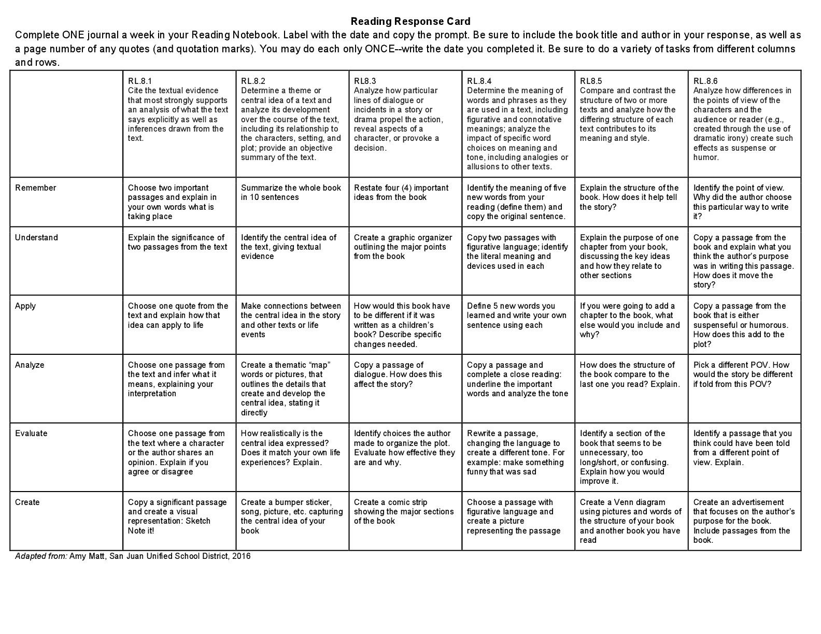

Appendix C

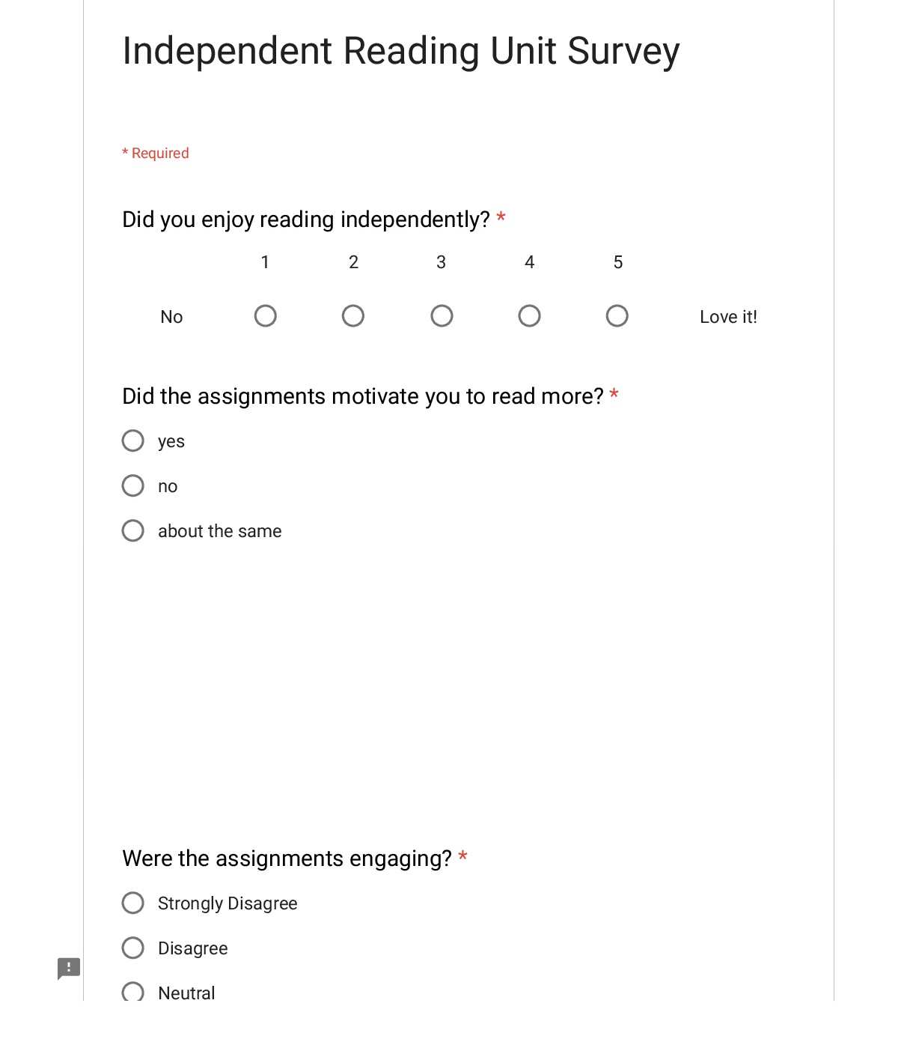
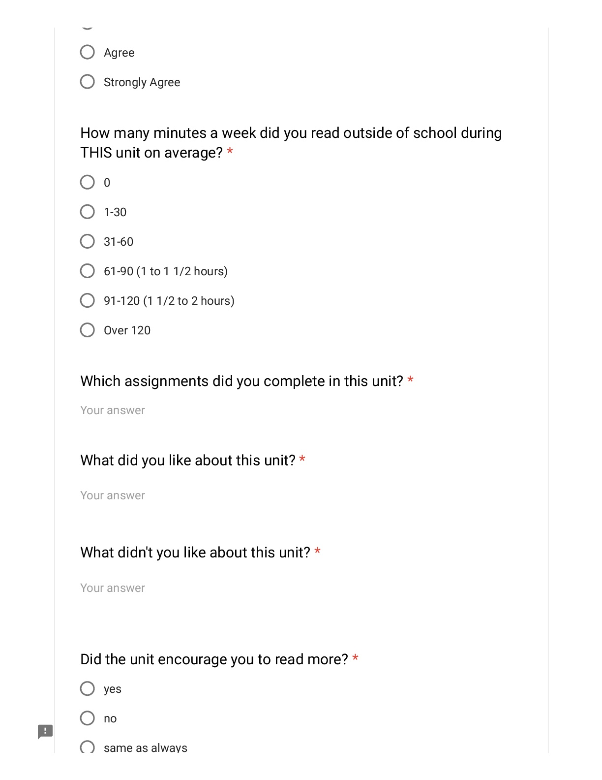
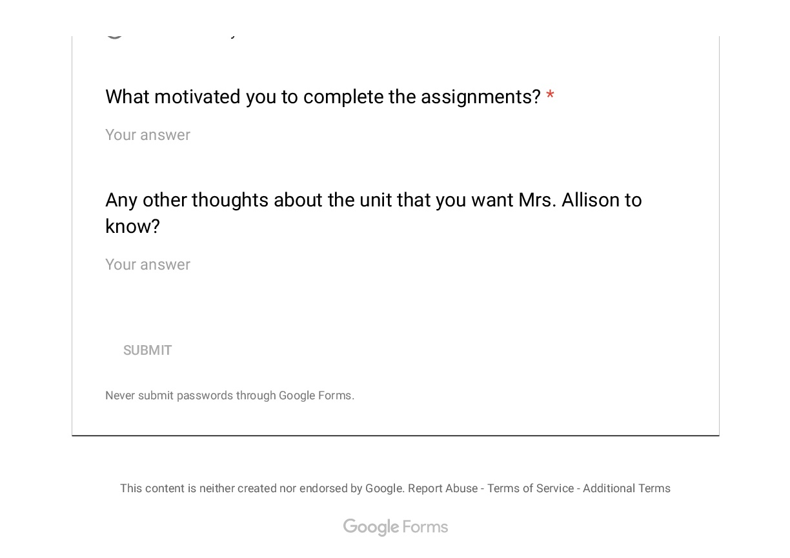

Appendix D 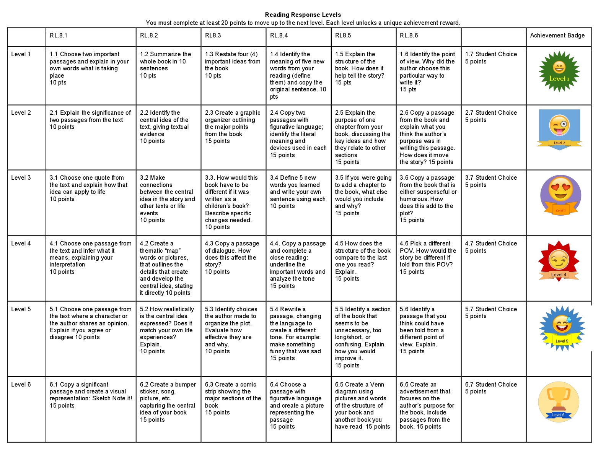

Appendix E