Ingredients for a Delicious (Interactive!) Presentation
How to Create Learner Centered Powerpoint/Google Slide Presentations

Kristina Allison
Josh Breese
Katie Haver

- Background/Context
  - Overview of objectives and outcomes
  - Needs Assessment

II. Ingredients:
  - Padlet (adding an interactive bulletin board to slides)
  - Youtube Videos (adding videos to slides)
  - Images and Memes (adding images and memes to slides)
  - Kahoot (adding an interactive game to slides)

III. Challenges
- Access to technology
- Techno-phobia

IV. Evaluation
- Formative evaluation
- Summative evaluation

V. Bibliography

Background/Context

Slide presentation software such as PowerPoint has become an integral part of many instructional settings. PowerPoint can be a highly effective tool to aid learning, but if not used carefully, may instead disengage students and actually hinder learning. (http://fctl.ucf.edu/TeachingAndLearningResources/Technology/PowerPoint/index.php).
- Powerpoint presentations tend to be “teacher-centered,” lack feedback, and reduce both critical engagement and student activity.
- In order to effectively use slide presentation software and applications teachers need continued support and training.
- Our professional development plan will provide teachers tools/ideas to create slide presentations that enhance student engagement and encourage student centered learning.

Overview of objectives and outcomes
1. Learners will get context about the need for learner centered presentations
2. Participants will learn tools for different components of learner centered presentation: how to use Youtube videos, Kahoot, Padlet and Memes to create engagement.
3. In groups, participants will use Google Slide or Powerpoint to create a presentation using the above components.

Needs Assessment
To determine the needs of our learners, we will use an online survey in which the teachers rate their use of various presentation applications for instructional purposes, as well as how often they implement technology into the classroom. The survey will include forced rating choices (daily, weekly, monthly) and open ended questions. The survey will be sent to teachers using Google Forms and the data will be exported into a Google Sheet.

Using a survey of teachers from the Roseville City School District as a source, we can determine there is a need for more effective use of technology in the classroom. Teachers have technology on a variety of levels but are not quite sure how to implement.
Survey results: https://goo.gl/VGRgWY Based on the survey, over 55% of teachers are using presentations often in their courses. However, students are not using technology as often in the classroom, with only 11% of teachers reporting a daily use by students. We would like to help make these presentations more engaging for the learner with interactive tools embedded in the slides and get students involved using technology.

At Sierra College, teacher observations were done to evaluate the need. Of the 12 professors observed, only 2 used PowerPoints at a Level of Technology Integration (LoTI) level of 3 or higher, meaning that most of the teachers I observed adopted PowerPoint into their lessons but did not integrate it well.
Furthermore, in an informal email to all faculty, they were asked if they would like to see more trainings on how to integrate PowerPoint into their classroom, and of the 10 responses, 10 responded positively to the idea of more trainings.
A more formal need assessment can be done on campus via surveys put out to all faculty. This need assessment can done through our research office.

Ingredients

Adding Padlet to your Presentations
Padlet is a virtual bulletin board that allows people to communicate in real time on a common space, with the ability to post videos, images, documents, and text from any device. When creating presentations, Padlet can be used as an engaging activity to discuss a common topic, it can set the tone by creating a collaborative environment. Some ways to incorporate Padlet into your presentations include the following:
- Book reviews
- Landmarks
- Vocabulary
- Quotes
- KWL chart
- Images

Getting started with Padlet
Go to www.Padlet.com
- Log in with your already established Google or Facebook account
OR
- Click on “Sign Up” to create a new Padlet account

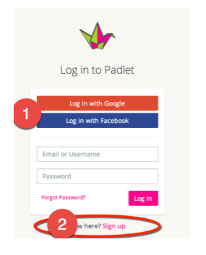
Creating your first wall
- Click on “Create new Padlet” to create a new wall.
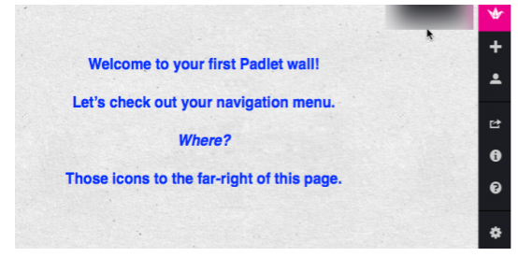
“Designing” and Managing your wall
1. When you select the “Modify Wall” (gear) icon, you’ll reveal the wall control menu.
2. Work from the top of this sub­menu, down to create your wall.
a. You can upload your own photos for both the portrait icon and the Wallpaper background.
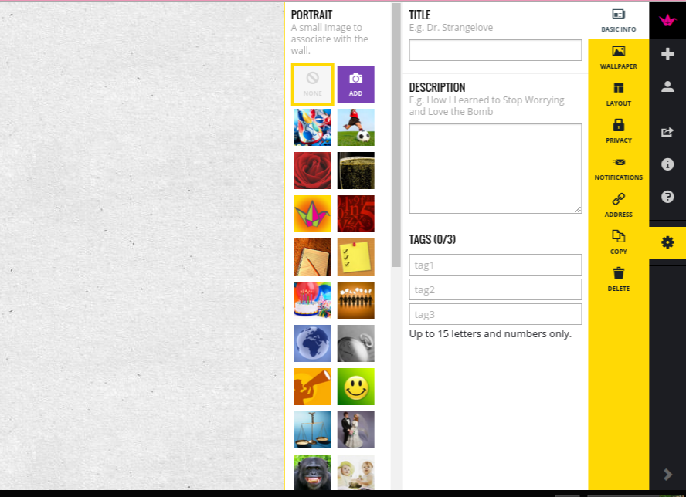
Wallpaper:
- Explore the wallpapers, which will become your background. There is a wide variety, some very useful like “My Tasks” or “Calendar”.
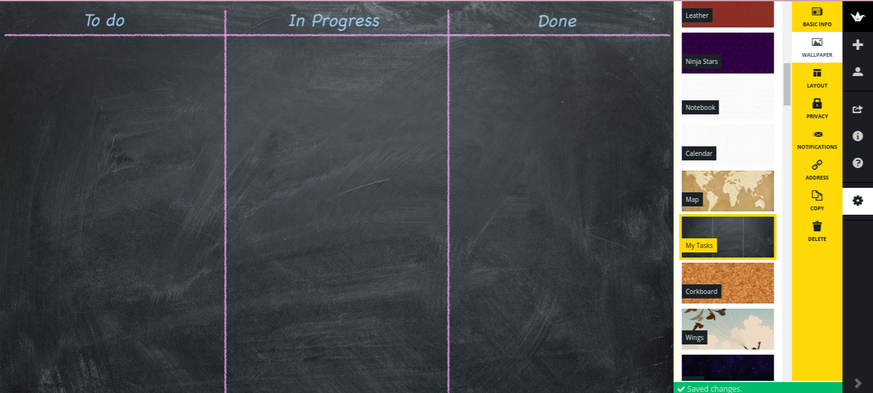
Layout:
- You can choose the layout of your “stickie” notes; freeform, stream or grid. Personally I think that the stream works best for a group, no overlapping of posts.
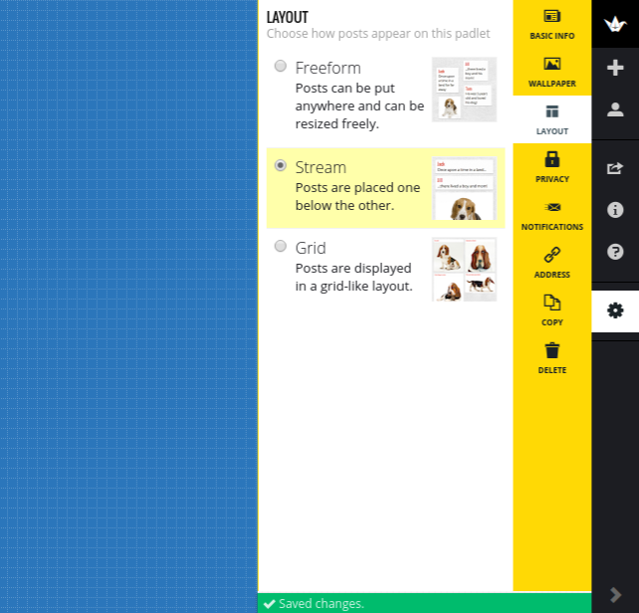
Sharing your Padlet page
- Create a “Custom” URL Padlet offers a cool feature, allowing users to “customize” a URL for free! Select the ADDRESS icon.
- Enter a potential URL in the “Pick a padlet.com address” option.
- When you get the green checkmark “Available”, select “PICK”
- Now, right­ click and COPY your new URL in the CURRENT ADDRESS box.
- Share with students and/or your collaborators.
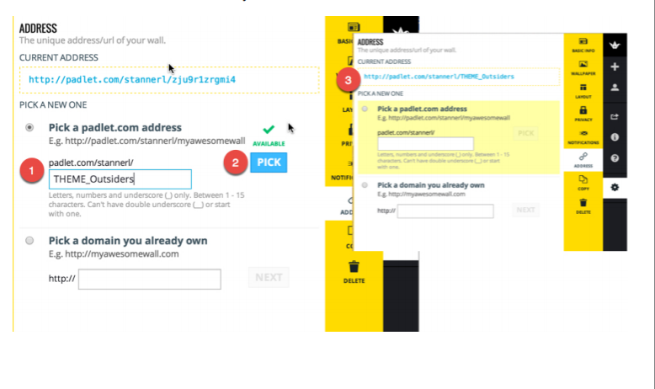

If you prefer to watch a video lesson on using Padlet.com try one of these video tutorials.
https://www.youtube.com/watch?v=UuzciL8qCYM
https://www.youtube.com/watch?v=KHWRi54nCn8

Adding Youtube Videos to your Presentations
Adding videos to your slide presentations not only makes your presentations more interesting to students, it will also enhance their learning experience. Video helps students connect better with content. By hearing and seeing content simultaneously, students have better cognitive recall. Be sure your videos are short though. Best use of videos are ones under three minutes. These “bite sized” videos can be used to demonstrate a concept or peak interest at the beginning of a lesson. Videos are a great resource for starting meaningful discussions, too. Try these effective techniques for student engagement:
- Play the video with no sound. Ask students to explain what is happening before playing it a second time with sound.
- Stop the video before the end. Ask students to predict what will happen.

Adding YouTube Videos to Google Slides:

Click on image for link to video:
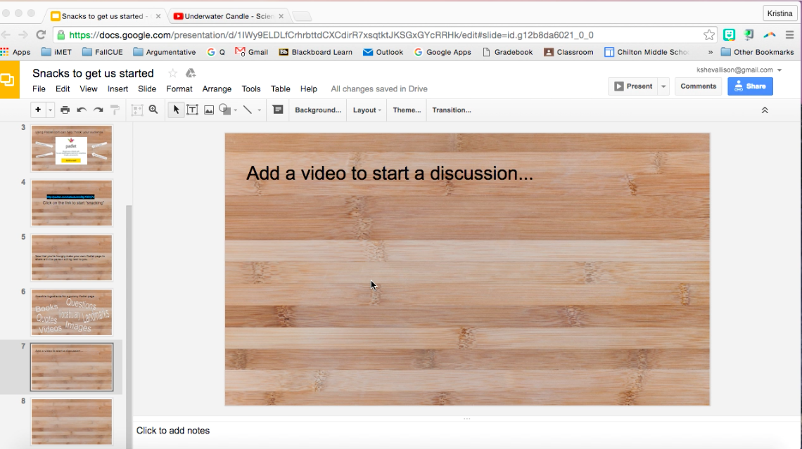

- Click the slide where you want to embed your YouTube video.
- Go to the “Insert” tab and then select “Video”.

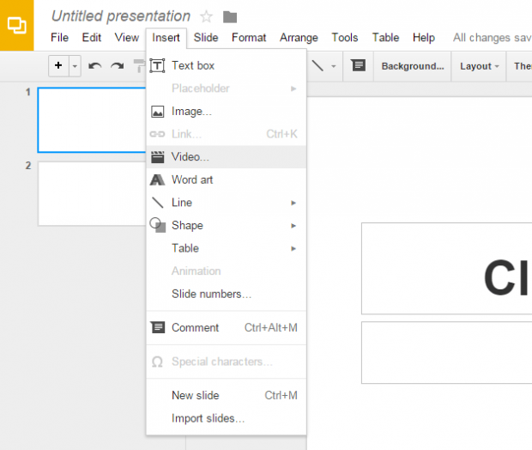
3. You can either choose to search YouTube for videos using the search bar or paste the direct YouTube URL.

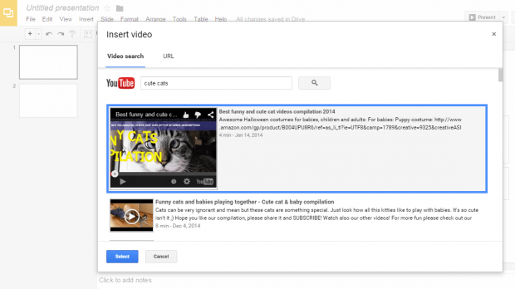
4. Select the video that you want. Click “Select” to confirm. The video will be added to your slide.
Powerpoint:
If you are working on a Mac, you must download the Youtube video as an mp4 file first, then insert as directed in the clip below:

Click on image for link to video:
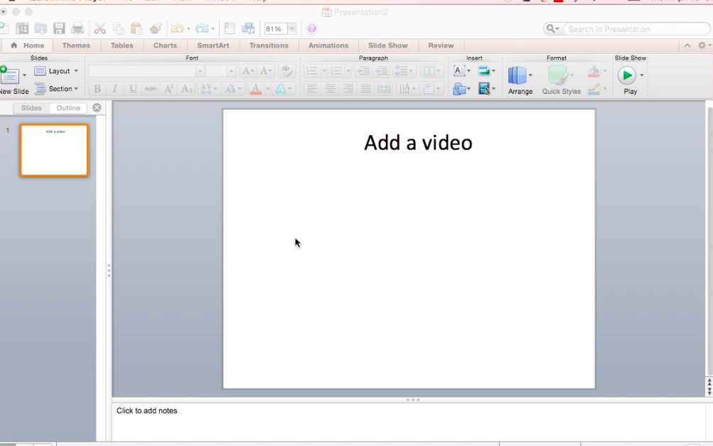

Directions for Windows:
If you know the name of the video hosted on YouTube, do the following:
1. Click the slide where you want to add a video.
2. On the Insert tab, click Video > Online Video.
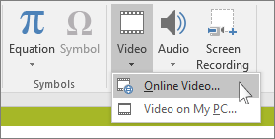
3. In the Search YouTube box, type the name of the video that you want to insert.
4. Select the video from the search results, and click Insert.
5. The video is placed on your slide, which you can move and resize. To preview your video on your slide, right-click the video, and then click Preview.
If you don’t know the name of the video hosted on YouTube, do the following:
1.Click the slide that you want to add a video to.
2. In YouTube, find the video that you want to insert.
3. Below the video frame, click Share, and then click Embed.
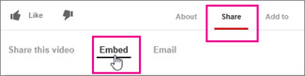
3. Right-click the iFrame embed code, and click Copy.
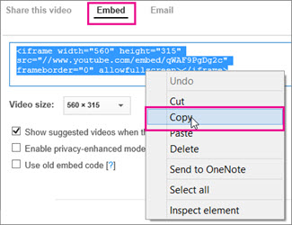
4. In PowerPoint, on the Insert tab, click Video > Online Video.
5. In the From a Video Embed Code box, paste the embed code, and then click the arrow.
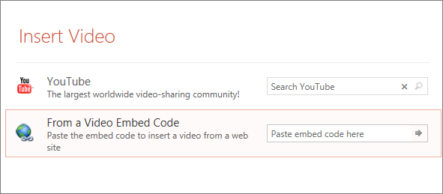
6. The video is placed on your slide for you to resize if you’d like.

Adding Memes to your Presentations

Memes are pictures or short videos that are spread quickly and virally on the internet. They are usually humorous, but can be used effectively to make a point or give the gist of an idea. When creating presentations for students, memes can be used to engage learners, simply by entertaining, but a meme can also have a cognitive effect, helping students remember a concept. For example:

Click on image for link to video:

The easiest way to do this is use an existing site. These have stock photos where you can simply add text, or you can upload your own picture. A few are:
https://imgflip.com
https://memegenerator.net
A quick Google search will turn up even more.

Next, have students create their own memes, focusing on something they have learned from your lesson. They can share them with a partner, group or post them on a Padlet. (See previous ingredient) Not only will this be effective in engaging students, it can serve as a quick check for understanding of content knowledge. Plus, students will find it fun. Tapping into a pop culture phenomenon can effectively engage learners.

Adding Kahoot to your Presentations
Kahoot is a web based application that is easy to add to a presentation. It will lead users to kahoot.it, where learners can take a quiz or a survey. Best of all, the application is free and easy to use.

To create a kahoot quiz, start by going to http://www.getkahoot.com and sign up for a free account. It only takes a few minutes.

Once you are signed up, sign in and go to http://create.kahoot.it and click Quiz, where the red arrow is pointing in the image below.
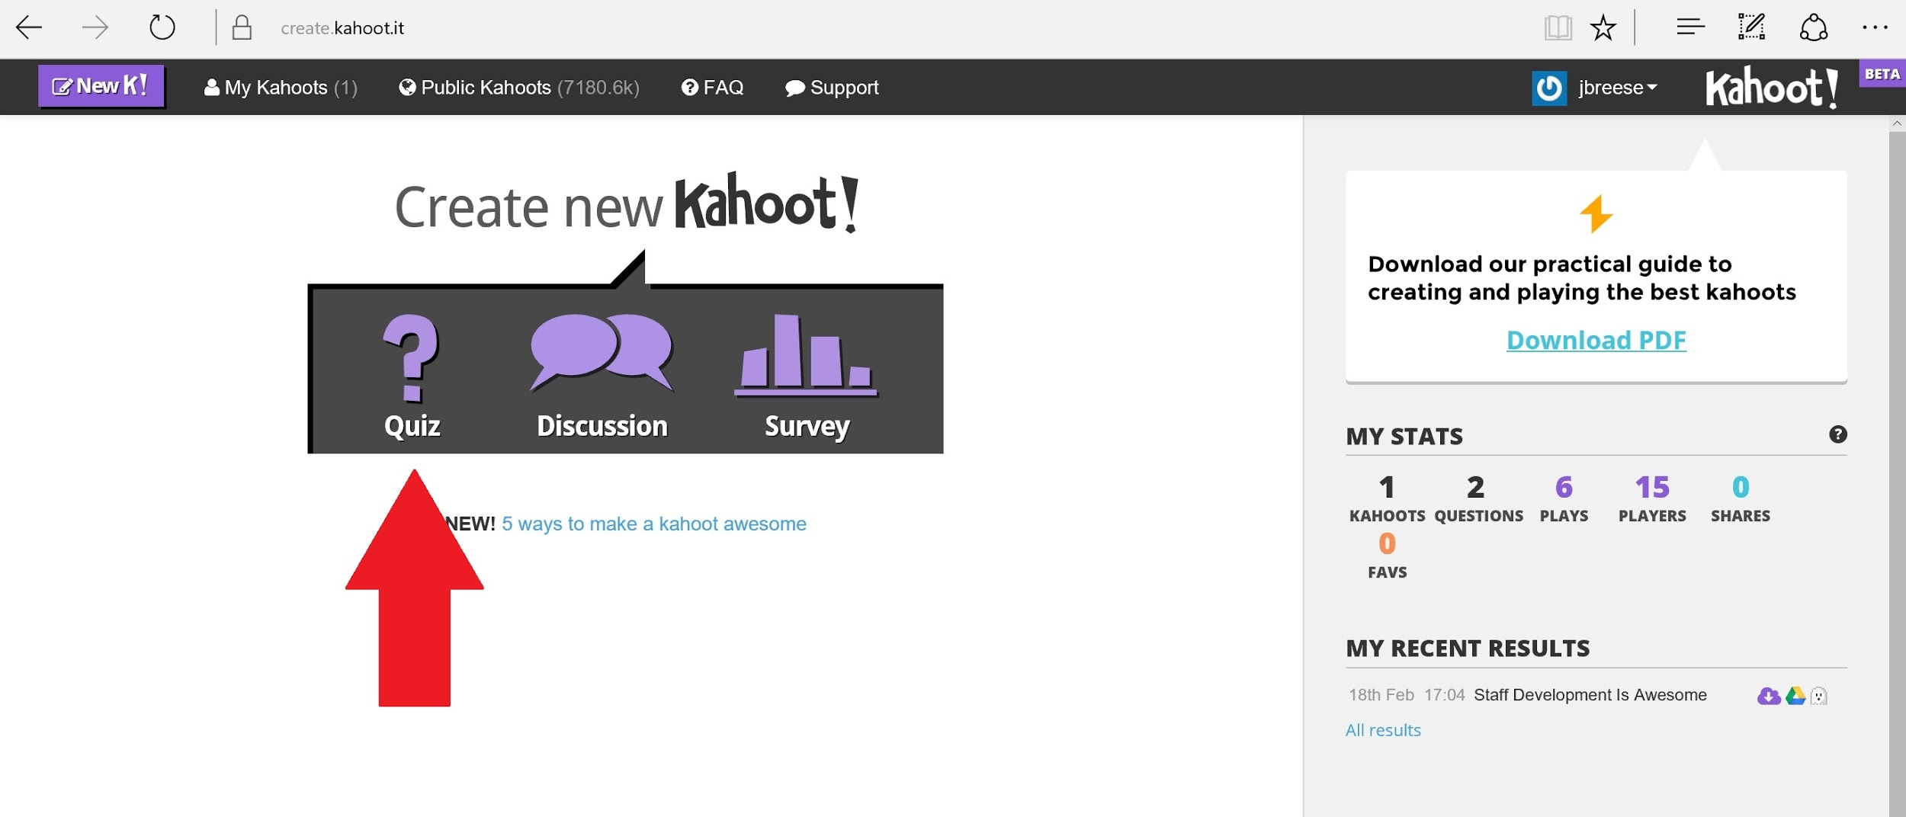

Next, you’ll see a screen like the one below.
Step 1. Ask a question by typing your quiz question in the box.
Step 2. (Optional) Add a video or picture by clicking on the “browse” button and uploading an image, much like you would an email attachment.
Step 3. Add answers. Be sure that you mark which answer or answers are correct by clicking the box below the answer.
Step 4. You have the option to delete the current question, create a new question in your quiz, duplicate the current question, or save and continue. Clicking save and continue will finish the quiz and move you to the next screen.
Ws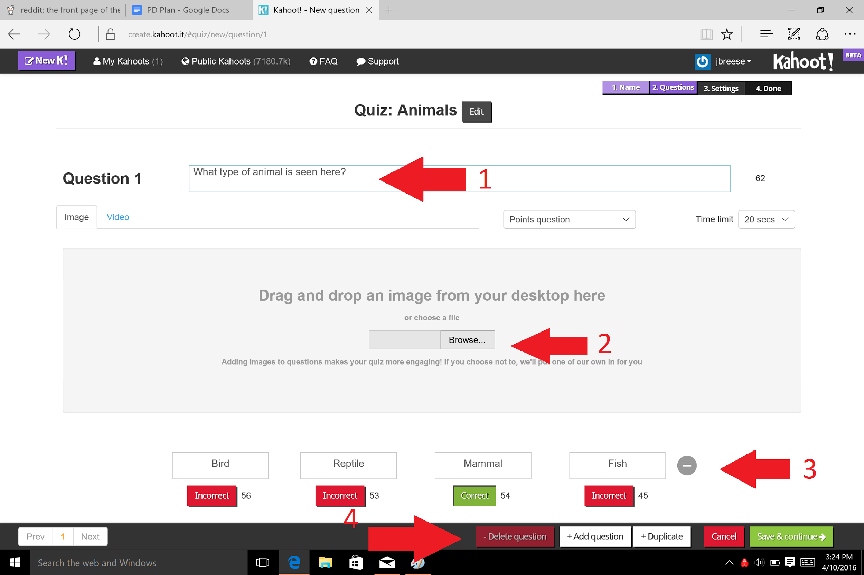

Once you are finished adding questions to your quiz, you’ll hit the “Save & continue” button in green on the bottom left.

Doing this will take you to the settings page (pictured below), where you can give more information about your quiz to your quiz takers. This is an optional step.
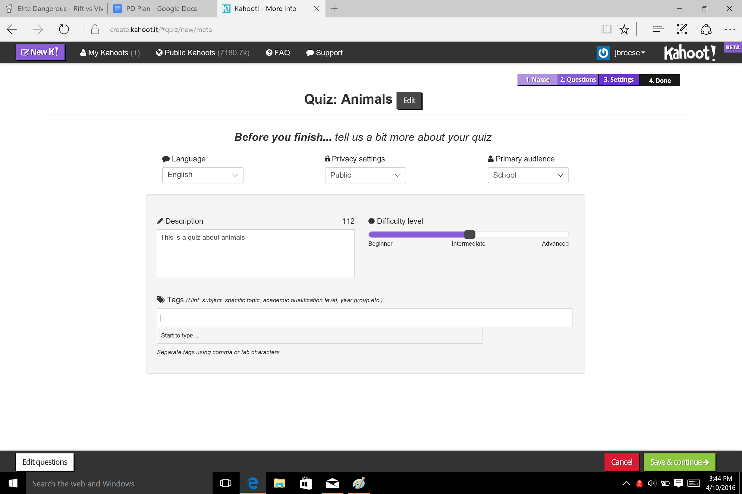

Once you’ve finished putting the final touches on your Kahoot, you will see a screen that says that you are Done! To see what your Kahoot quiz looks like, press the “Preview” button.
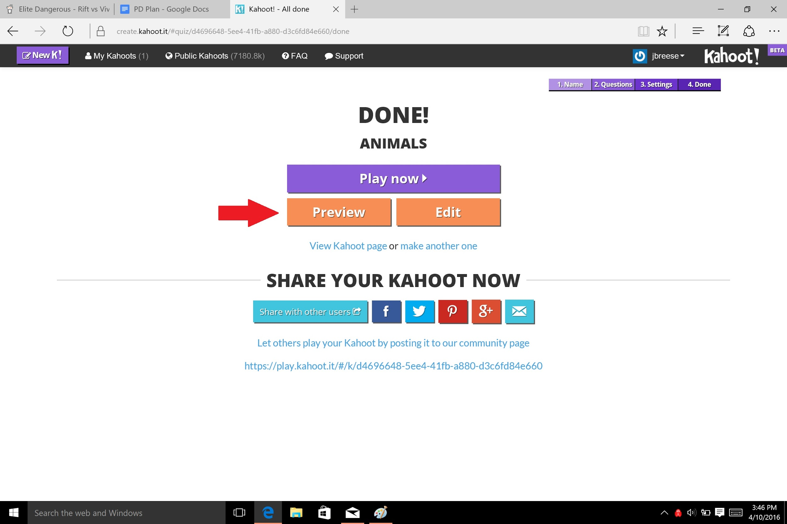

The preview button will take you to a screen that shows you two things, what you will see on your computer as the quizzer, and what your students will see on their smart phones. It is a good idea to run through the preview a couple of times to familiarize yourself with the interface.
First you will click “Launch.”

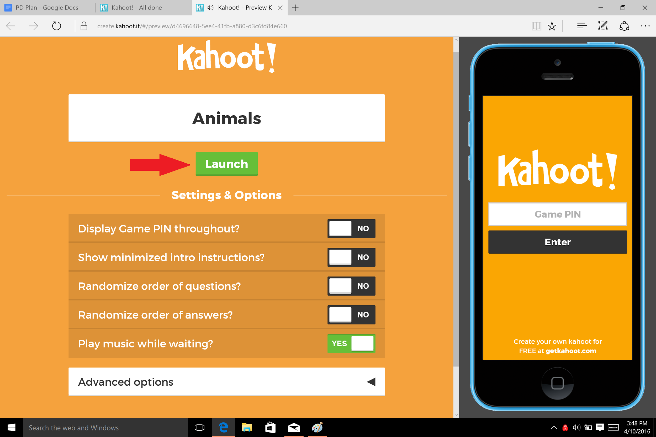

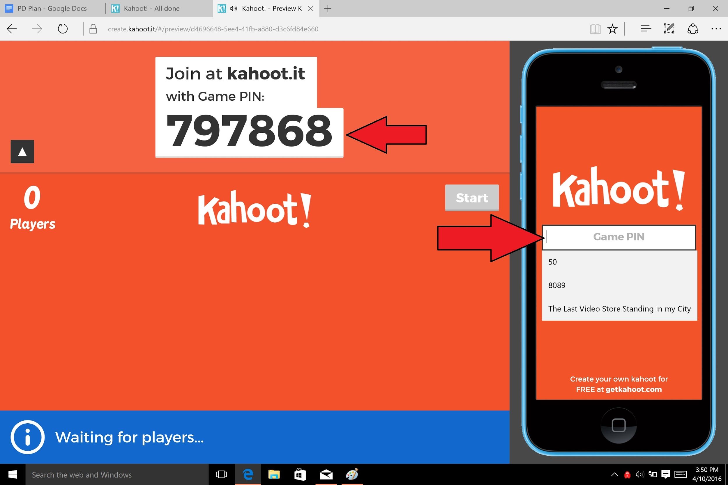
You’ll see that the phone has a screen that says game pin. When you play the game with your students, they will enter the game pin that is presented after you launch your quiz. Make sure they enter the pin in correctly, as it may take them to the wrong Kahoot!

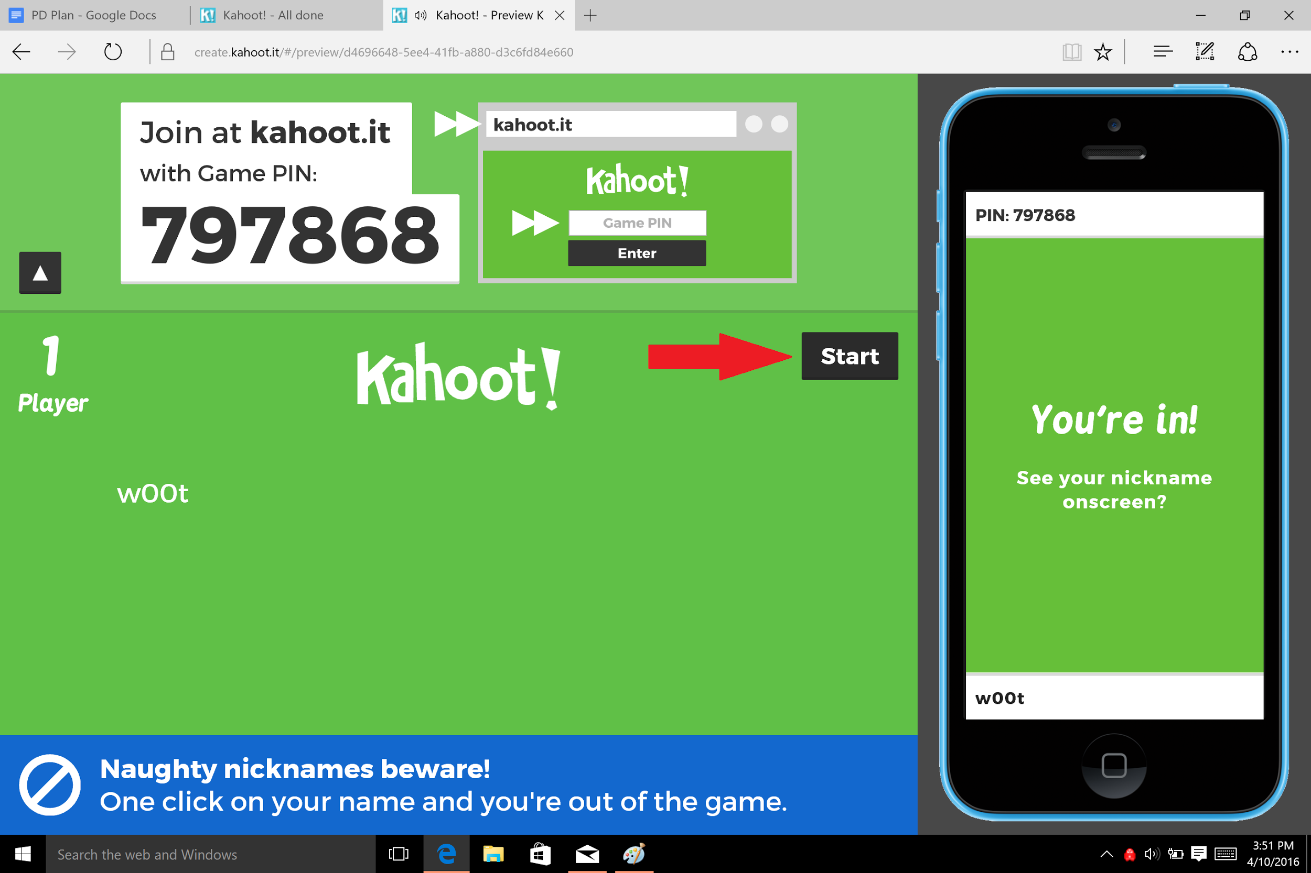
You will see a player counter marking the number of players. Furthermore, students can put their own username in once they put the game pin in. This allows them to be anonymous. You can tell your students to put their real names in, though, if you’d like.

Once everyone has joined, click the “Start” button.

Now the quiz has begun! You will see the smartphone change into a gamepad that reflects the answer choices. It is a good idea, for the first time you play with your students, to put one or two practice questions so that they get the hang of answering.
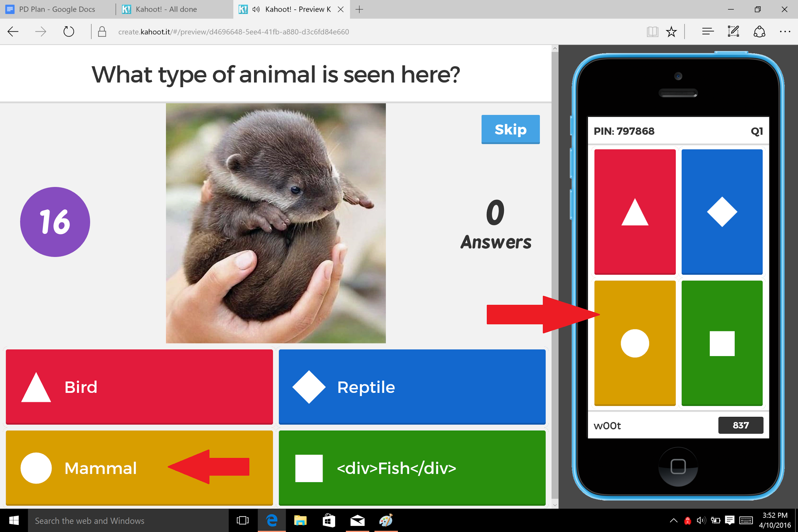

That’s it! That is the basics of Kahoot! There are some more options to play with, so feel free to experiment!
Or, if you’d like a more detailed look at Kahoot! and the many options, check out one of these training videos:
https://www.atomiclearning.com/k12/kahoot-training
https://www.youtube.com/watch?v=pFFv6_6was4

Challenges
- Access to technology is always a concern when your presentation depends on it. It is best to check that there is an internet connection and an LCD projector. It will also be important that the participants bring and/or have access to a laptop, desktop or tablet.
- Technophobia is the fear or dislike of advanced technology or complex devices. According to the National Center for Education Statistics the average age of the public school teacher is 42.5 years old, most earning their teaching credential before technology was an essential component of every day instruction. Many teachers feel intimidated by new technology and/or do not have the time necessary to research new technologies to integrate into their daily lessons. The formative assessment given before the training should help identify the skills of the learners and let the learners know what to expect from the training.

Evaluation

As technology enters the classroom more and more each year, there are an increasing number of innovative applications that educators can use to create interactive presentations. One such application that has been used for years is Microsoft’s Powerpoint program and in more recent years Google Slides. When used effectively both of these applications can enhance teacher presentations and student comprehension. However, when used ineffectively Powerpoint or Google Slides presentations can be less effective than traditional teaching methods. Many teachers are afraid to use technology because they are uncomfortable with the tools and/or lack the professional development on how to integrate these tools into their lessons. This professional development plan was designed to introduce teachers to online tools that can be used to enhance their Powerpoint or Google Slides presentations.

To evaluate the effectiveness of this professional development participants will be given a survey before the training, at the end of the training and then a follow-up survey about 4 weeks after the training. We have kept the questions brief because we have found that to get the most participation, the questions need to be concise.

Before Training/Formative Assessment:
The assessment given before the training will identify the current role and experience of the learners. This assessment will be given on the first day of the training.

- What is your role?
  - Teacher (what level)
  - Trainer
  - Administrator
  - Support Staff
- I am comfortable using Google Slides or Powerpoint
  - 1-5?
- How often do you use Google Slides or Powerpoint to present information in class? (daily, weekly, monthly, not at all)
- Have you used Padlet.com with your class? Yes or No
- Have you included videos into Google Slides or Powerpoint? Yes or No
- Have you used Kahoot.com with your class? Yes or No

Summative Evaluation:
The summative assessment will be given at the end of each module (Padlet, Kahoot, Youtube) to evaluate each segment of the training.

- The goals of the training were clear
Strongly Agree Agree Disagree Strongly Disagree Not Applicable
- The materials were easy to understand
Strongly Agree Agree Disagree Strongly Disagree Not Applicable
- The pace of the training was manageable
Strongly Agree Agree Disagree Strongly Disagree Not Applicable
- I have learned something useful today
  - What?
- I am excited to bring this back to my colleagues
Strongly Agree Agree Disagree Strongly Disagree Not Applicable
- I am excited to use this with my students
Strongly Agree Agree Disagree Strongly Disagree Not Applicable
- The most valuable part(s) of the “Ingredients for a Delicious (Interactive!) Presentation” were:

- I would make the following changes to the workshop:

- I would like to see a follow-up training about:

- I’m going to use this part in my classroom starting next week:

- Additional comments:

Follow-up survey (approximately 4 weeks after training):
This survey will be emailed to the participants with follow-up questions regarding implementation of the strategies covered in the training.

- How often do you use Powerpoint or Google Slides? (daily, weekly, monthly, not at all)?
- Have you created a new and/or changed a Powerpoint or Slides presentation since the training?
- Have you used Padlet.com with your class?
- Have you used Kahoot.com with your class?
- Have you included videos into Google Slides or Powerpoint?

Bibliography

Education, U. D. o. (2004). Table 19. Average age of public school teachers and distribution of teachers by sex, and state: 2003–04. Retrieved from https://nces.ed.gov/surveys/sass/tables/state_2004_19.asp
Effective use of PowerPoint. (2016). Retrieved from http://fctl.ucf.edu/TeachingAndLearningResources/Technology/PowerPoint/index.php
Insert or link to a video on YouTube. (2016). Retrieved from https://support.office.com/en-us/article/Insert-or-link-to-a-video-on-YouTube-8340ec69-4cee-4fe1-ab96-4849154bc6db
Padlet for beginners. (2016). Retrieved from http://www.aea1.k12.ia.us/documents/filelibrary/school_technology/tech_in_the_classroom/padlet/Padlet_for_Beginners_3A66E0A4BC13B.pdf
Stanic, T. (2014). Why you should add video to your teaching. Instructional design. Retrieved from https://blog.edynco.com/instructional-design/why-you-should-add-video-to-your-teaching/

Appendix

Agenda
- Introduction of Facilitators
- Background and Context
  - Pass out formative assessment
  - Need for training
  - Need for creativity
  - Need for learner centered technology in the classroom
III. Opening Up the Mystery Box
Ingredients:
- Padlet (adding an interactive bulletin board to slides)
- Learners will be asked to consider ways to “hook” the audience (What are the ingredients for a tasty hook?)
- Learners will need internet access; Padlet can be accessed on a Smartphone, tablet, laptop, or PC.
- Learners will be directed to http://padlet.com/katiedurk/o3tgi1951j7d
- Each person will be asked to make a post on the group Padlet page
- Finally the learners will be given ideas to make their own Padlet page and then given time to create a Padlet page and share with the person sitting next to them (possibly the facilitators will ask learners to paste their links on a shared Padlet page for all to access or share in Google slide show)
B. Youtube Videos (adding videos to slides)
- Learners will be asked to search Youtube for a video clip of their favorite movie
- Learners must then write two discussion questions about the clip
- As a group, we can share and discuss how this could be used in a presentation.
- Learners will then learn to add the Youtube clip to a presentation

C. Images and Memes (adding images and memes to slides)
    - Learners will see a series of memes
    - Discussion on how this technique can be used in a presentation to connect to content.
    - Learners will create their own Memes

D. Kahoot (adding an interactive game to slides)
    - Split learners into teams.
    - Each team needs at least one laptop, and most of the members need to have smartphones or a tablet.
    - Each team needs to go to https://getkahoot.com/
    - Teams will have 10 minutes to create a kahoot quiz to be played by everyone at the event. The quiz must be at least 5 questions long.
      - We want the learners to figure it out for themselves. However, the PD facilitators will be floating around with tips, tricks, and just-in-time training.
    - The teams need to share their kahoot on the group google slideshow.
IV. Questions and Discussion
V. Summative Feedback Survey

